Filtering a Water Sample

Equipment and supplies needed:
- Gloves
- 1 Nalgene reusable filter unit
- Hand vacuum pump
- Vacuum tubing, 18” length
- 1 nylon membrane filter, 0.45 µm pore, 47 mm diameter

Notes:
- Rinse the support plate, upper chamber and receiver with clean deionized water when the unit arrives and air dry before using.

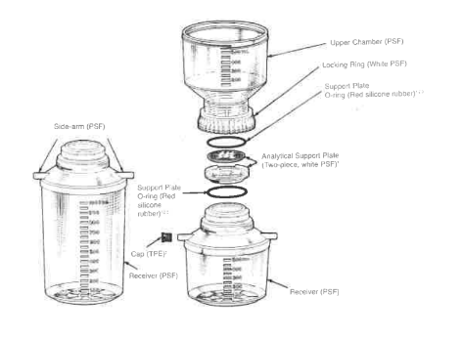

Steps

Assemble the filtration unit:
- Locate the upper chamber, analytical support, and receiver of the filtration assembly.
- Place the support plate with the O-ring into the top of the receiver.
- Place a clean filter membrane onto the support plate with forceps.
- Place the upper chamber with the O-ring onto the support plate and tighten the locking ring.
  - Make sure the filter membrane doesn’t get a bubble underneath it. If this happens, loosen the locking ring
- Seal one of the side-arms of the receiver with a cap (if not already done).
- Connect the hand pump to one end of the vacuum tubing.
- Connect the other end of the vacuum tubing to the open side-arm of the receiver.

Filter the water sample:
- In the field:
  - Remove the top cover on the receiver and using the water sampler valve, pour ~150 mL of water from the bottle into the upper chamber.
  - Close the water sampler valve and place the water sample to the side.
- In the lab:
  - After collecting the water sample in a cleaned 250-mL amber Nalgene bottle and transporting it back to the lab while kept cold on ice, pour ~150 mL of water from the bottle into the upper chamber.
- Operate the hand pump to draw the water sample through the filter assembly into the receiver, pressure should be kept around 0.4 for optimal flow over the membrane.
- The water in the receiver has been filtered for use in Nitrogen (DIN), Phosphorus (SRP), and Silicate (SIL) nutrient analysis.

Disassemble the filtration unit:
- Detach the tubing from the hand pump and side-arm of the receiver.
- On the filter unit, undo the locking ring and remove the upper chamber (make sure the O-ring is transferred with the upper chamber).
- Remove and discard the filter membrane.
  - If the filter could be used again (i.e. not too much particulates coating the surface), rinse with 1N HCl and 3x deionized water. Air dry on a kimwipe or clean surface.
- Remove the support plate (make sure the O-ring is transferred with the support plate).
- Rinse the support plate and upper chamber with deionized water and allow it to air dry.

